**TO DELETE SUBSCRIPTION TOPIC IN ACL PROFILE**

Before deleting the exceptions in publish topic

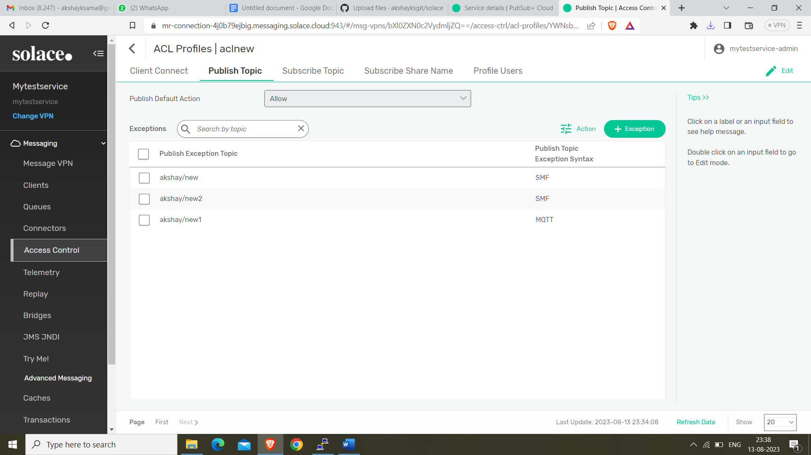

After deleting